Assignment No: 01
Name: Dnyaneshwari Thombal
Class: SY-1
Batch: C
PRN: B25CE2005

Title: Rainfall Tracking:
Write a program to track rainfall data for 3 cities over 4 months. Using a 2D array, we can store the data, calculate the average rainfall for each city, and display the rainfall data in a tabular format.

Program:
#include <iostream>
using namespace std;
int main(){
int cities=3;
int months=4;
int Rainfall [cities][months];

cout<<"Enter temperature data for 3 cities for 4 months:\n";
for (int i =0;i<3;i++){
cout<<"City"<<i+1<<"\n";
for(int j=0;j<4;j++){
cout<<"months"<<j+1<<":";
cin>>Rainfall[i][j];
}
}
cout<<"\n Rainfall data table";
cout<<"City\nmonths\t";
for (int j=0;j<4;j++){
cout<<"Month"<<j+1<<"\t";
}
cout<<"Average\n";
for(int i=0;i<3;i++){
int sum=0;
cout<<"cities"<<i+1<<"\t";
for(int j=0;j<4;j++){
cout<<Rainfall[i][j]<<"\t";
sum+=Rainfall[i][j];
}
int average=sum/months;
cout<<average<<endl;
}
return 0;
}

Output: 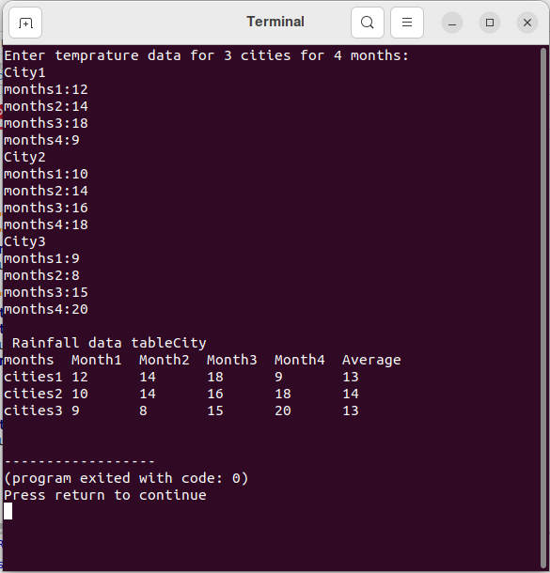

Title: Temperature Tracker:
Write a program for Tracking daily temperatures of 3 cities for a week. The program calculates the average temperature for each day and for the week.

Program:
#include <iostream>
using namespace std;
int main(){
int cities=3;
int days=7;
int temperature [cities][days];

cout<<"Enter temperature data for 3 cities for 4 months:\n";
for (int i =0;i<3;i++){
cout<<"City"<<i+1<<"\n";
for(int j=0;j<7;j++){
cout<<"day"<<j+1<<":";
cin>>temperature[i][j];
}
}
cout<<"\n Temperature data table";
cout<<"City\ndays\t";
for (int j=0;j< 7;j++){
cout<<"Day"<<j+1<<"\t";
}
cout<<"Average\n";
for(int i=0;i<3;i++){
int sum=0;
cout<<"cities"<<i+1<<"\t";
for(int j=0;j<7;j++){
cout<<temperature[i][j]<<"\t";
sum+=temperature[i][j];
}
int average=sum/days;
cout<<average<<endl;
}
return 0;
}

Output:
